Murmansk to Morocco:
A myriad of missions in snow and sand

The Bf-110 campaign that spans the war, 1939- 1945

Built and described by 1.JaVA_Sjonnie
Tested by WTE_mobi, AirBone and Fool_Trottel

for IL2 FB + AEP + PF (v4.04m or up)

With custom skins from www.il2skins.com and www.1java.org

Introduction
I made this campaign because the Bf 110 was in action on virtually every front, from snow to sand, or Murmansk to Morocco, fulfilling many different tasks.
Many historians discard the Bf110 as a failure, some do not. I personally have the impression that it wasn’t always deployed the right way, especially during the battle of Britain; when it was used as a “Jabo” it was actually quite good. Also, it was an excellent night fighter.
So, one could also say that while the 110 was no good as a day fighter, it was a good Jabo, photo recon plane, bomber interceptor and excellent as a night fighter.

Difficulty level is user determined!
You can set the difficulty yourself. The “normal” settings should enable you to complete them all with some success. The missions are flyable at any difficulty, but FR fans will find that the briefings may not always give exact target coordinates. In such cases I recommend you either let the autopilot bring you to the target, or use the direction finder to get there (see under “difficulty levels”).

Historical elements
This campaign will show you what happened in the 1939- 1945 air war with a degree of historical correctness; however, only a few of these missions are 100% historical. The basis of 90% is semi- historical, based on dates and actual fact, re- created in such a way that the player can feel what it was like and see how things happened. Whenever possible, I match skin choice to unit.

In places where aircraft have been used that seem historically incorrect, I have chosen to replace a historical but non- available type with an available type. In “1940 01 Fall Gelb” this is the case because the Fokker D-XXI is not yet available in 4.04m, this has been replaced by the Hawk 75, which is almost correct as it had been ordered by the Dutch but they took delivery of them in the East Indies and they never were in Holland.
Also, I am quite well aware of the fact that of the Bf110 the G2 version did not become operational until late in 1942 and in strength in 1943.

Missions: how to enjoy them to the full
Most missions are much, much shorter than those in real life. They are also more eventful than that.
I like my missions to be realistic yet entertaining, though sometimes that is hard to achieve. If you allow yourself to use external views, you will find that many times there is plenty of action below (except when flying high, or at night) so I recommend you put the autopilot on after take-off (or whenever) and take some time to see the action (with ctrl+F2 etc), which usually starts early. When you reach your first target it’s wise to switch back to manual.
I never fail to put static camera’s in.
The number of flights is never more than 9-10 altogether but more likely to be 8 or less in most cases, with a total number of 12 to 16 planes. I hope my missions do not overload your system; they work well on mine.

Use of autopilot and tactics
The autopilot does not always make wise choices; I recommend flying by hand when encountering enemy planes, to make sure you don’t dogfight when you’re supposed to do something else. Find the primary target on the briefing map, read the description and you’ll know when to fight and when to take evasive action.

Difficulty levels and finding your way
I recommend to start the campaign with a lower rank like Oberfeldwebel.
If you like to fly in FR (realistic) difficulty level you should know that finding the way to the target and back is easier than most people know, just as low flying can be made easier if you know some details about the Bf110. Also there are some helpful instruments to make survival easier.
To follow waypoints even when you can’t use the map, use the Direction finder (1). Just point the little aircraft on the indicator straight up, like in the picture, and you are following your planned route.
To know how close you actually are to the ground use the ground proximity gauge (2) which moves down from 750m to 0m and gives actual altitude, unlike the the altimeter in most cases. This is the thing to keep an eye on when you’re flying really low.
The amount of ammo left can be seen on the ammo counters (3). The middle one is for MG or MK108, the outer ones for the MG151/20.
Are you going up or down? Look at the vertical speed indicator (4). If the needle goes up, you go up.

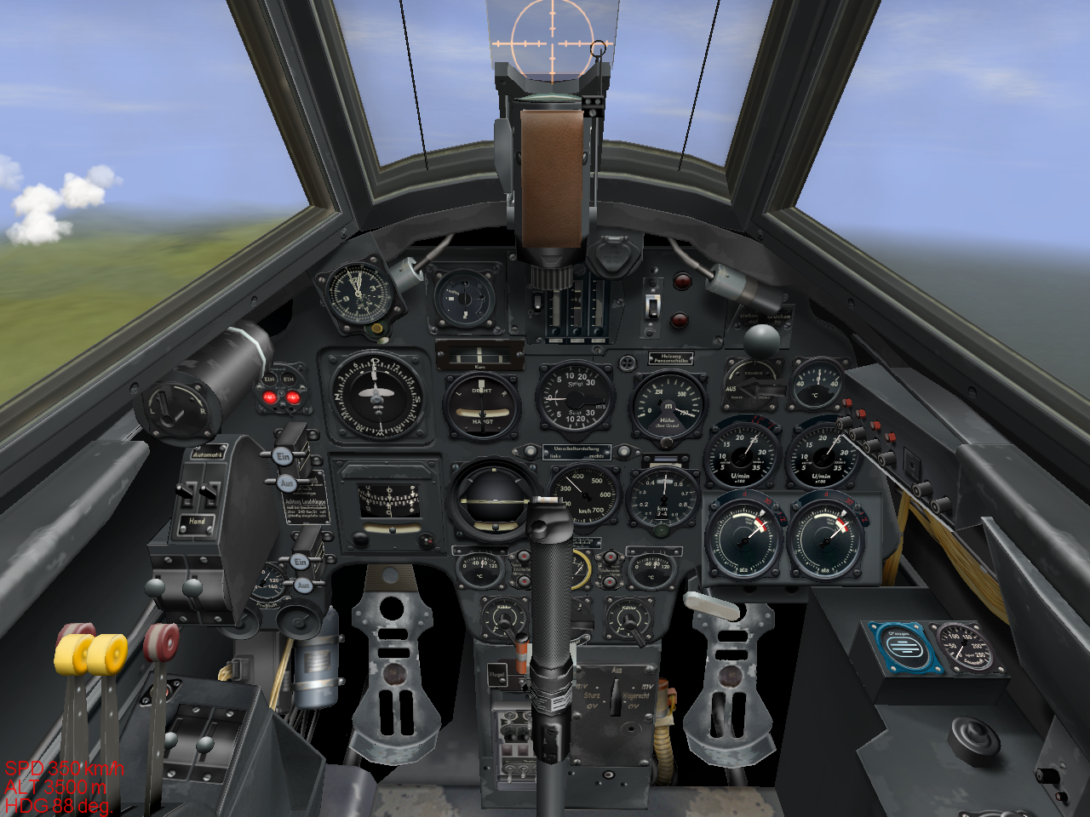
1
2
3
4

Sim version and installation

This campaign will run on a merged installation only. Version should be 4.04m or higher.

To install, first extract the mission zip file (110_Campaign.zip) to your IL-2 FB folder. Make sure you have the option “Use foldernames” enabled and everything goes into the right directory. You just have to move the background image if you want to use it.

Skin pack:
This is a separate ZIP-file to keep the download as small as possible. Extract the Bf110 SKINS zip file (Bf-110_Skinpack.zip) in all 3 Bf110 skin directories: 110C-4, 110C-4/B and 110G-2. For a standard installation that would be:
C:/program files/ubi soft/il2 sturmovik forgotten battles/Paintschemes/Skins/110C-4
C:/program files/ubi soft/il2 sturmovik forgotten battles/Paintschemes/Skins/110C-4_B
C:/program files/ubi soft/il2 sturmovik forgotten battles/Paintschemes/Skins/110G-2

Also, a separate “splash” comes with the campaign. To have a Bf110 background when your mission loads, you should put the files “background.mat” and “background.tga” in the folder
C:/program files/ubi soft/il2 sturmovik forgotten battles/missions/campaigns/DE/
and don’t forget to rename the original background in case you want to change it back.
You should now be ready to get going. Select “pilot career” from the main menu and select Germany, and then select the campaign called “Bf110 WWII campaign by 1.JaVA_Sjonnie” . Don’t forget to set your difficulty level BEFORE you fly, because you can’t change it later.

Sources
I used books by Nowarra, Schliephake, Green, Mason, Griehl, van Ishoven, Ziegler, Rudel, Galland, Swanborough, Hooftman, Bowyer, Taylor, Molenaar and a couple more. Most of the front lines are from the detailed maps in the “atlas of the second world war” by Young and Natkiel.
The skins are from several artists who make some extremely good looking skins, usually near perfect. You should have a look at www.1java.org or www.il2skins.com. Thanks guys.

Disclaimer
I’m not a Bf110 fan or historian, and my interest is purely technical.
I have no political intent with this campaign. Also it should be noted that the skins were NOT made by me. I downloaded them all from the sites mentioned above.
Some of the skins have swastikas, these are there because it appears to be historically correct and are not intended to glorify anything to do with whatever it stood for.
I totally reject Nazism and everything it stood for.

